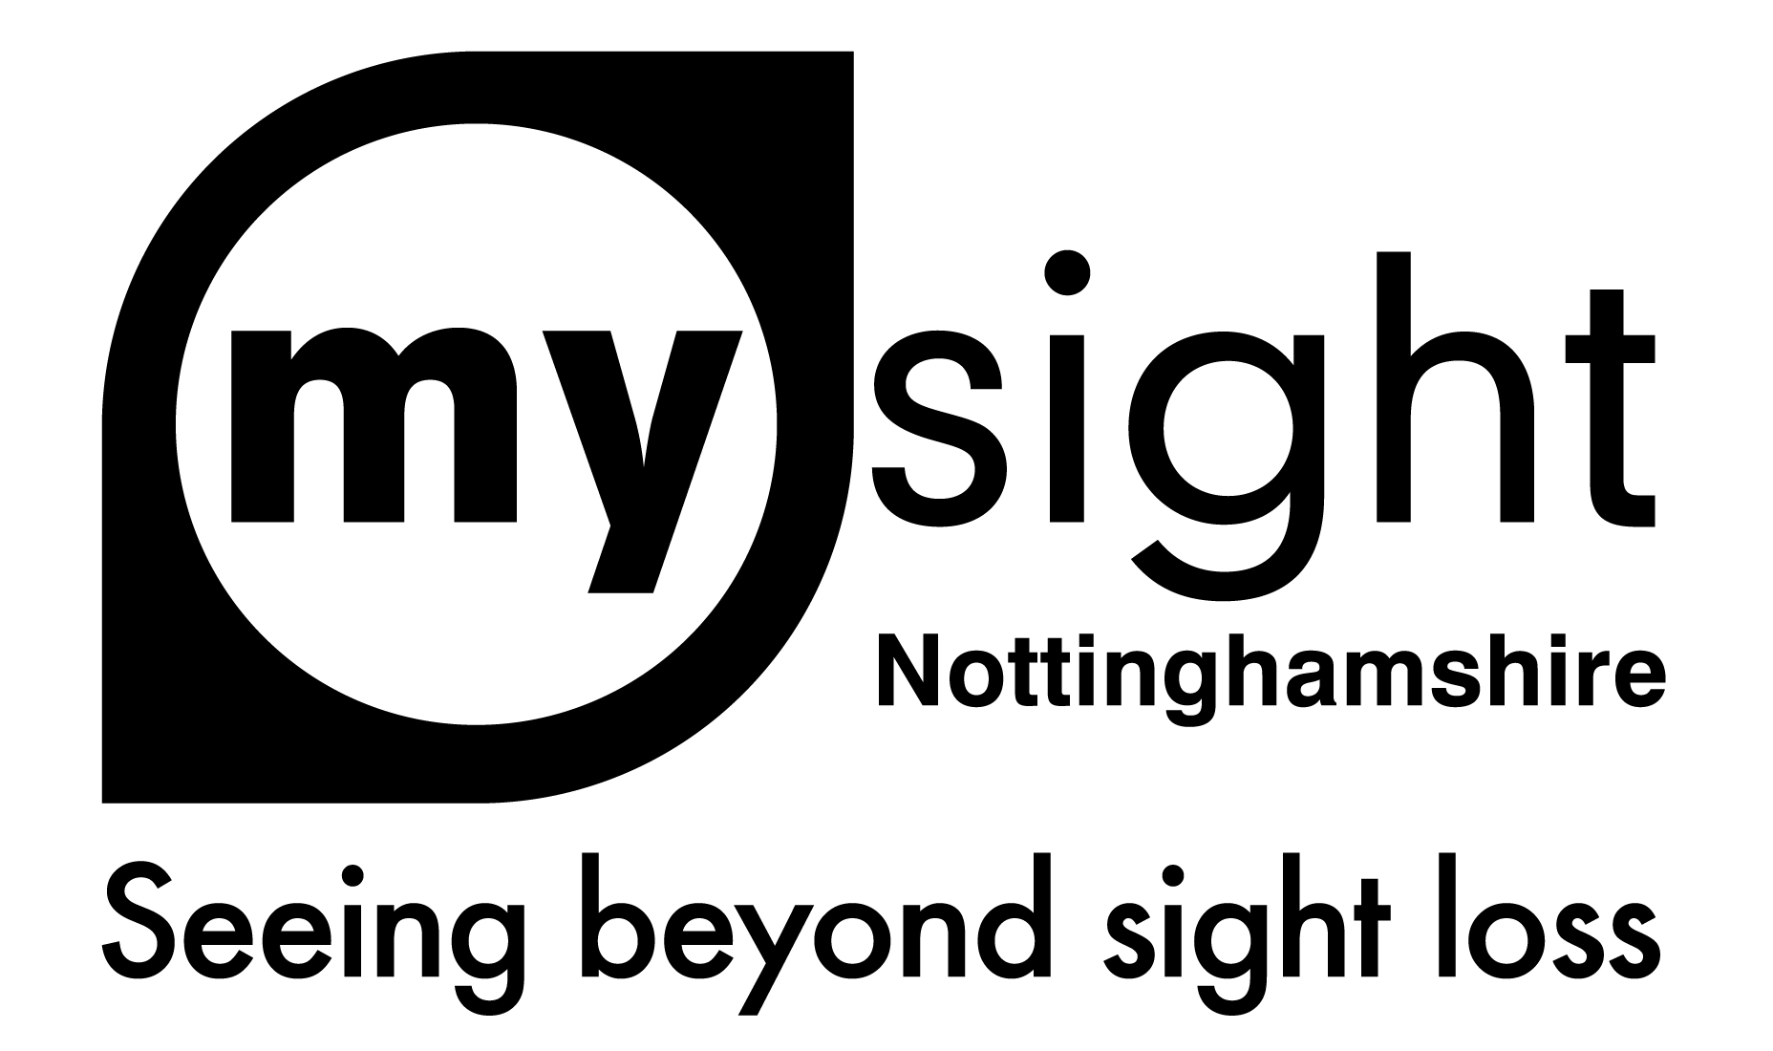

Services Update
August/September 2023

Our Senior Sight Loss Advisor, Donna Goldberg, is going off on maternity leave. Her last day will be 8th September. We wish Donna and Dan all the best and can’t wait to see baby Goldberg!

During Donna’s absence, I am pleased to announce that Abbie McPhilbin, our Employment Advisor, will be taking on additional hours and duties as a Sight Loss Advisor alongside her Employment Role.
Shared Vision
Michele Banton, our Shared Vision Coordinator, is now back from her three-month sabbatical, where, I am assured, she had a fabulous time in New Zealand!

This means our Shared Vision sessions are back up and running. Shared Vision supports you with emotional and practical support, enabling you to share your experiences with other’s going through a similar journey. If you would like to book on the course, please call us on 0115 970 6806 or email us at info@mysightnotts.org.uk to request a referral form.
Mansfield Tech Support Hub
We have a brand-new group starting at Mansfield Library, Four Seasons Centre. West Gate, Mansfield, NG18 1NH.

The Mansfield Tech Support Hub will be held on the 2nd Wednesday of each month from 13th September on the main floor of the library. The sessions will be from 11am to 12.30pm and 1pm to 2.30pm.

There is no need to book, we will operate a drop-in service. Please bring your phones, tablets and laptops and our Sight Loss Advisor will be able to support you with software, updates, accessibility, apps and much more.
Talking News
The latest local Nottinghamshire and My Sight Notts news delivered straight to your door on a memory stick or CD. This is posted out every two weeks in a bright yellow wallet. Just listen, pop it back in the wallet, turn around the address card and then pop in the post box. No postage is required as items are sent via the Articles for the Blind Scheme. All it costs is £5 a year.

From January 2024 we will no longer be offering the news on CD. This is due to a number of reasons. We are happy to support people to swap over to USB and will be happy to demonstrate the USB players that are available.

For more information or to register for the talking news please contact Sarah Briggs, Sight Loss Advisor, on 0115 9706806 or email sarahb@mysightnotts.org.uk

Newmedica Health Event
As part of National Eye Health Week My Sight Nottinghamshire and Newmedica have organised a health event for Tuesday 19th September 2023. This event will be held at Newmedica, Unit 1B and 1C Midland Place, Barlborough Links, Chesterfield, S43 4FR between 10am and 2pm.
There following organisations will be attending:
- My Sight Nottinghamshire - general information about the organisation, our My Sight Bassetlaw social group and our Employment Service
- Sight Support Derbyshire
- Blind Veterans UK
- Macular Society
- Healthwatch
- ADVIS

There will also be the opportunity to have your blood pressure and blood glucose checked.

For more details, please contact Sarah Briggs, Sight Loss Advisor on 0115 9706806 or email sarahb@mysightnotts.org.uk

Services for Professionals
My Sight Notts has been developing its services for professionals. We have been delivering a transcriptions service for a long time and decided to build on this. We now offer:

- Transcriptions into Braille, large print and audio
- Room Hire – hire rooms at Heathcoat Street, Nottingham
- Accessibility Audits – we can support you to ensure your premises and literature are accessible
- Digital Accessibility Group – a group of service users and volunteers that can test out apps, websites and software to ensure it is accessible for people with sight loss
- Sight Loss Awareness Training – for healthcare professionals – we can deliver at our premises in Nottingham or at your premises

We are delivering fully funded Sight Loss Awareness training for healthcare professionals from September. If you are interested, or know of someone that may be interested, please contact us on 0115 970 6806 or email info@mysightnotts.org.uk.

