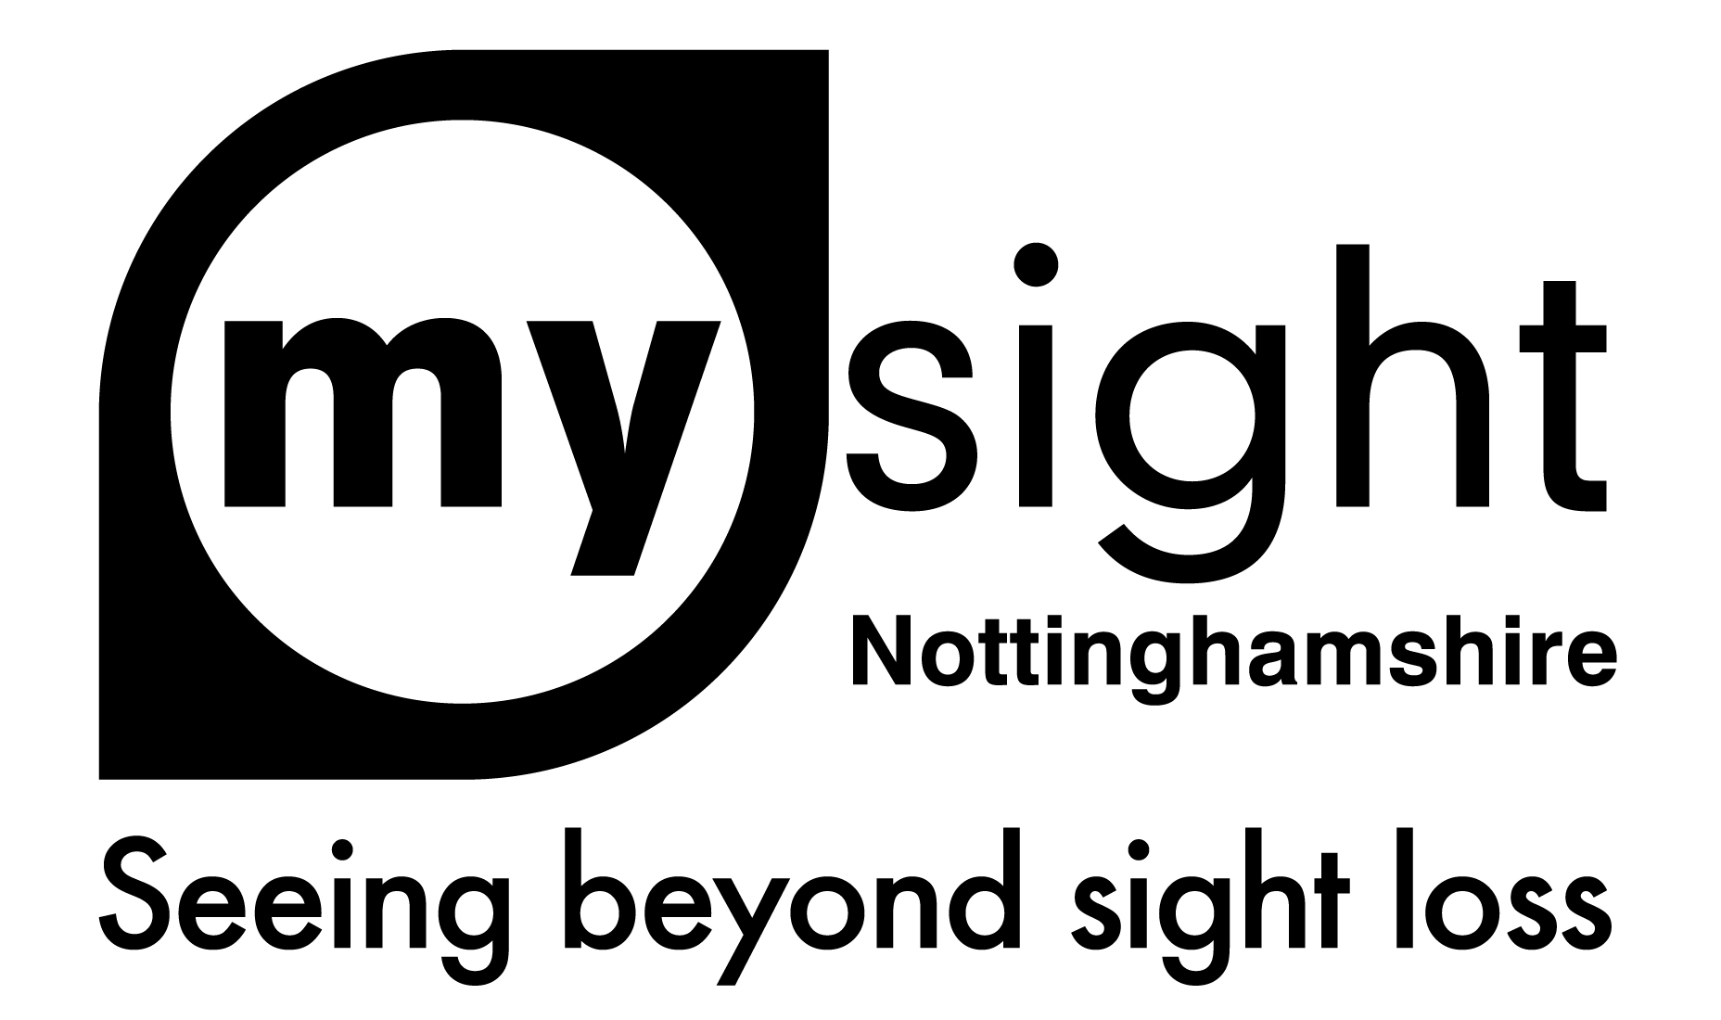
The Big Sale
We have a huge number of items that have been discontinued, donated or are ex demo or ex stock. You can find out more information about these items on our website www.mysightnotts.org.uk and visit the Sale Aids and Equipment page.
Lighting
LED Twist Lamp WAS - £42 NOW - £15

Table Magnifier Lamp WAS - £35 NOW - £10

Magnifiers
7x Eschenbach Hand Magnifier WAS - £40 NOW - £20

12.5 x Eschenbach Hand Magnifier WAS - £60 NOW - £25

Schweizer 6x Hand Magnifier x 2 WAS - £60 NOW - £10

Multi Powered Pocket Magnifier WAS - £10 NOW - £5

Corded Mono Mouse WAS - £60 NOW - £30

Amigo HD 7in Electronic Magnifier WAS - £795 NOW - £200

Reading Machines
Smart Reader HD OCR WAS - £1570 NOW - £250

ReadEasy+ (Older Model) WAS - £1200 NOW - £75

Desktop Magnifiers
Magnilink Zip Folding Desk Magnifier WAS - £3500 NOW - £350

Clearview+ Desktop Magnifier WAS - £1800 NOW - £400

Music / Audio Book Player
Sovereign USB Player WAS - £55 NOW - £10

Sovereign 2 USB Player WAS - £55 NOW - £10

Sonic 2 USB Player x 2 WAS - £55 NOW - £10

CD Audio Books (2 available) WAS - £25 NOW - £5

Solo USB Personal Audio Player WAS - £66 NOW - £30

Communiplayer USB (No charger) WAS - £35 NOW - £10

VictorReader Stratus4 Daisy Player WAS - £325 NOW - £75

Clocks & Watches
Silver Talking Keychain WAS - £9 NOW - £5

Communiclock Talking Clock WAS - £35 NOW - £10

Talking Cube Clock x 2 WAS - £32 NOW - £10

Talking Calendar Alarm Clock WAS - £42 NOW - £20

W2 Talking Wristwatch – Plastic WAS - £10 NOW - £7.50

W6 Gold Easy to See Watch - Bracelet WAS - £13 NOW - £5
Bracelet Strap

W10 Talking Calendar Watch WAS - £17 NOW - £5

RNIB Talking Watch – Touch Glass WAS - £52 NOW - £25
Small, White Leather Strap

Small LP Watch – Velcro Strap WAS - £20 NOW - £5

Large LP Watch – Leather Strap WAS - £20 NOW - £5

Talking Radio Controlled Watch WAS - £25 NOW - £10

Technology
Synapptic Bluetooth Keyboard x 1 WAS - £65 NOW - £25
Yellow on Black

Doro Secure 580 Mobile Phone WAS - £100 NOW - £30

BT200 Landline Phone WAS - £30 NOW - £10

Household
Learning Remote Control WAS - £12 NOW - £5

Band It’s WAS - £10 NOW - £5

Universal Remote-Control x 2 WAS - £20 NOW - £5

Sok Loks (Pack of 10) WAS - £4 NOW – £1

White Non Spill Mug WAS - £20 NOW - £10
Penfriend Labels
Set D x 5 packs (one open) WAS - £13 NOW - £5
(Large Square & Small round)

Set E x 2 packs WAS - £13 NOW - £5
(Large Square & Small round)

Magnetic Labels x 10 WAS - £13 NOW - £5

Games
Braille Happy Families WAS - £5 NOW - £3

Draught Pieces only NOW - £1

Miscellaneous

Tactile Stickers for children NOW - £1

Reizen Braille Labeller with Tape WAS - £39 NOW - £15

Cocoon Shades – M/L – Boyensberry WAS - £32 NOW - £15

All items are checked as much as possible to make sure they are working correctly.

All sale items are non-refundable and do not come with a guarantee. All watches and clocks will have new batteries fitted, if required.

If you have any questions about these items please contact Sarah, Sight Loss Advisor by email sarahb@mysightnotts.org.uk or call 0115 9706806.

You can also find pictures of the items on our website www.mysightnotts.org.uk

