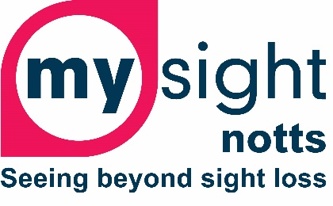

Referral list Telephone

Statutory Services (Rehabilitation)
Nottingham City Council 0300 131 0300
Nottinghamshire County Council ADVIS 0300 500 8080
Derbyshire County Council Sensory Team 01629 533190
Derby City Council Sensory Services 01332 640000
Lincolnshire Sensory Services BID 03333 202667
Lincoln City Council 01522 881188
Leicestershire County (Vista) 0116 249 8839

Local Charities
My Sight Nottinghamshire 01159 706806
Sight Support Derbyshire 01332 292262
Vista (Leics and Rutland) 0116 249 8839
Lincoln and Lindsay Blind Society 01507 605604
South Lincs Blind Society 01476 592775

National Charities
RNIB 0303 123 9999
Guide Dogs UK 0845 372 7499
The Macular Society 0300 3030 111
Blind Veterans 0800 389 7979
Retina UK 0300 111 4000
Glaucoma UK 01233 648170
Esme’s Umbrella 0303 123 9999
Sense UK 0300 330 9256
Deaf Blind UK 0800 132320
The Partially Sighted Society 01302 965195

Child and Parent Support
Look UK 07464 351958
Victa Kids 01908 240831
Royal Society for Blind Children 0203 198 0225
Alstrom Syndrome UK 07970 071675
Microphthalmia, Anopthalmia and
Coloboma Support (MACS) 0800 169 8088

Community Low Vision Services
Nottingham City, EMMS Low Vision referral form: EMMS Healthcare

