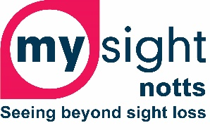

**To all our supporters, service users and volunteers, we wish you all a very merry Christmas and a happy,**

**peaceful and safe New Year.**

**With best wishes from all the trustees,**

**managers and staff at My Sight Notts.**

**My Sight Notts Christmas Opening times**

Our offices in Heathcoat Street, Nottingham will be closed from lunchtime on Tuesday 24th December re-opening at 9.30am on Monday 6th January 2025.

We recognise that this may be a difficult time for some. Please see below for support services over the Christmas period.

**Salvation Army**

The Salvation Army run a variety of services over Christmas including food parcels, Christmas dinner and support. Local number s are as follows:

Nottingham 0115 950 3827

Mansfield 01623 652 021

Sutton in Ashfield 01623 442 665

Hucknall 0115 963 4881

Worksop & Retford 01909 475806

Newark 01636 640 097

**Samaritans** 116 123 (free)

**Silverline** 0800 470 8090 (free)

Silverline is a free confidential helpline providing information, friendship and support for older people.

**Childline** 0800 1111

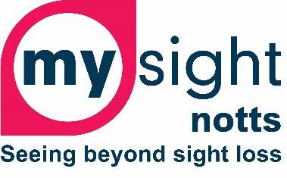

**My Sight Notts Services Update**

Our services are here to support you to lead an independent life. If you would like any more information on the following, please visit our website [www.mysightnotts.org.uk](http://www.mysightnotts.org.uk), call us on 0115 970 6806 or email us at [info@mysightnotts.org.uk](mailto:info@mysightnotts.org.uk). Please note that there is a small charge for some of our services to help towards costs.

**Counselling** - We have recently been successful with some funding that will allow us to provide one to one counselling sessions with a qualified counsellor, supporting you with your emotional and mental health, giving you some of the tools to adapt to a life with sight loss.

Alternatively, we also offer one to one counselling with our student counsellors.

**My VisAbility Employment Service** – supporting you to gain the skills and confidence to move nearer to, move into, or stay in employment.

**Tech and IT Support –** supporting you with all aspects of IT and tech. Drop-in IT group every Monday and Wednesday at our offices in Heathcoat Street, Nottingham from 1pm to 4pm. We can also come and visit you in your homes.

**Equipment and Advice Centre** - provides advice and practical hands-on equipment demonstrations and training at our Heathcoat Street centre with one of our Sight Loss Advisors.

**Shared Vision** - a series of workshops (held over a period of three days or for 2 hours weekly over video conferencing software) that help you to come to terms with your sight loss by focusing on the practical and emotional effects of sight loss.

**Eye Clinic Liaison Officer (ECLO)** - based in the Macular Clinic on B Floor at Queens Medical Centre in Nottingham, our ECLO is there for when you may need some support coming to terms with your sight loss diagnosis. They offer practical advice and emotional support and can refer you to other My Sight Notts services or external services.

**Social groups** – our social groups meet in Nottingham, Mansfield, Newark and Worksop. They deliver a range of fun activities, practical activities, speakers, trips and much more. The groups meet at different times so please get in contact for details.

**Coffee Morning** – our coffee morning meets every other Tuesday at our premises on Heathcoat Street, Nottingham. It offers opportunities for you to meet other people with sight loss.

**Gym & Swim** - Our swim and gym sessions run weekly on a Tuesday from 10am to 12pm at Victoria Leisure Centre, Sneinton, Nottingham. We offer support to use the gym equipment and around the venue. Swimmers with sight loss have their own lane of the pool, enabling you to swim independently and safely.

**Walking Groups** – **Walkie Talkie Wednesdays** meets every 1st and 3rd Wednesday of each month at 10.30am. Meeting places vary depending on whether we travel to the walk by bus or tram.  All walks finish at a pub, cafe or restaurant for lunch. Our **Rambling Group** meets on the 2nd and 4th Saturday of each month at 9.15am. Meeting at the Nuthall Pub, Nottingham Road, Nuthall, Nottingham, NG8 6AX, the group will walk between 6 and 8 miles at places across Nottinghamshire and Derbyshire.

**Choir** – our choir meets every 2 weeks on a Monday where they learn songs that are then sung at several events throughout the year.

**Talking News** – a local news and information service that is sent out to you every 2 weeks by digital download or USB stick. Recorded by our amazing volunteers, Talking News also includes book reviews, quizzes, interviews and much more.

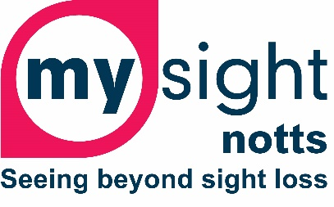

**Nottingham Light Night 2025**

Nottingham Light Night is where the city comes alive with light-based installations, performances and other activities across the city centre. Light Night is a free, family friendly event that brings light and warmth to the city.

Earlier this year we carried out an accessibility audit of Light Night and came up with some suggestions to make it more accessible for people with sight loss.

As such, Its In Nottingham (who put on Light Night every year) is working with us to ensure that everyone can enjoy Light Night 2025.

We are working on:

* Audio descriptions for each installation piece to ensure they are accessible
* Audio described routes
* Guided tours that will start and end at My Sight Notts premises on Heathcoat Street, in the city centre.

Light Night 2025 will be on Friday 28th February and Saturday 1st March next year. There will be more information on our website and socials nearer the time but if you are interested, please just get in touch on 0115 970 6806 or email [info@mysightnotts.org.uk](mailto:info@mysightnotts.org.uk).

If you’d like to see more about Light Night, please visit last year’s website here:

<https://www.itsinnottingham.com/news/nottingham-light-night/>