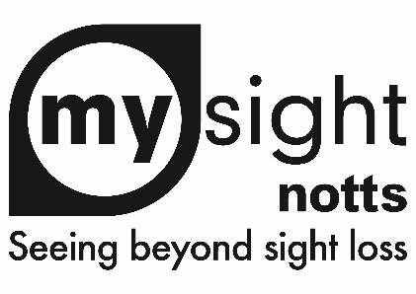

**Services Update**

This month (March), we say goodbye to two of our amazing members of staff. Michele Banton has been running our Peer Support and Shared Vision services for over 8 years. Michele will be travelling to Canada to visit family. We are very much going to miss her!

Kirsty Allen will also be leaving us to chase her dream of owning her own nutrition business. We wish her every success and we will very much miss her too!

We are currently recruiting for Kirsty’s role so please watch this space! However, we have now recruited Kate Buchanan to take over our Shared Vision service. Kate has a background in occupational therapy and will be a fantastic addition to the staff team here at My Sight Notts. Kate will start with us in May and we can’t wait to welcome her.

**IT Group**

We are re-launching our IT group with a new name and a new focus. Our new ‘Tech Bytes’ sessions will continue to be a drop-in session on Monday and Wednesday afternoons at our premises on Heathcoat Street. We invite you to come in for a social hour or two, have a drink and a biscuit (and even cake on the odd occasion!) and meet other like-minded people where you can share knowledge and experience of apps, devices, websites, accessibility and much, much more.

One of our Sight Loss Advisors will be on hand to support you with any queries you have and to make the tea!

For more information, please contact Alan hart on 0115 970 6806.

**National Eye Health Week**

This year, National Eye Health Week will be bigger and better than anything we have done since 2019! The week will be from 23rd to 29th September 2025 and we are looking to have a range of activities across the county. Please save the dates!

If you have any ideas for activities or you would like to offer your support, please do get in touch with Sarah at [sarahb@mysightnotts.org.uk](mailto:sarahb@mysightnotts.org.uk) or call 0115 970 6806.