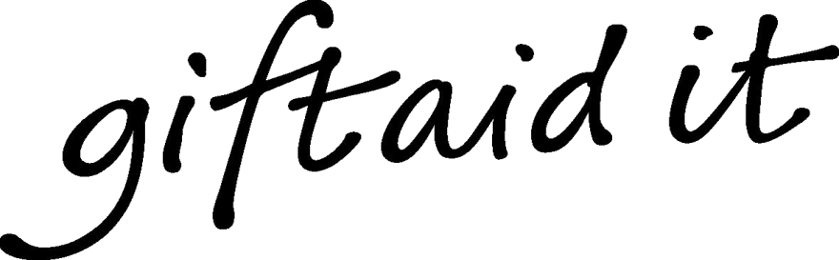

Title:.............. Forename(s):........................... Surname: ............................................................

Home Address: ................................................................................................................................................

...........................................................................................................................................................................

...........................................................................................................................................................................

Postcode.................................................

Phone (Optional) .................................... Email (Optional) ......................................

• I understand that the items I have left will be sold by My Sight Nottinghamshire, on my behalf, as my agent. The Goods remain my property until they are sold.

• I understand that I can keep all or part of proceeds of the sale subject to a commission charge of 35% of the sale plus VAT.

• I confirm the donated goods belong to me and that I am not acting as a business. If HMRC deems I am acting as a business I accept I am potentially liable to income tax and VAT on any proceeds from the sale of the goods even if the proceeds are donated to the charity

• I understand that any unsold goods can be disposed of by My Sight Nottinghamshire at their discretion

• I understand that I will not be contacted automatically when an item is sold, but that I can request a total value of the sale of my goods, at any time.

• I understand that any trader that asks a charity to sell trading goods on their behalf will need to include the full proceeds in their receipts and any commission charged as expenses in their accounts when calculating their taxable profits and when a charity is selling valuable goods on their behalf, any Capital Gains Tax liability will remain the traders own responsibility

**This Agency Agreement is a legally binding contract between the donor of the goods and the charity, as agent, in the sale of the goods Gift Aid**

**Declaration**

**Boost your donation by 25p of Gift Aid for every £1 you donate!**

Gift Aid is reclaimed by the charity from the tax you pay for the current tax year. Your address is needed to identify you as a current UK taxpayer. In order to Gift Aid your donation you must tick the box below:

I want to Gift Aid this donation and any donations I make in the future or have made in the past 6 years to My Sight Nottinghamshire: I am a UK taxpayer and understand that if I pay less Income Tax and/or Capital Gains Tax than the amount of Gift Aid claimed on all my donations in that tax year it is my responsibility to pay any difference. Please notify the charity if you:

• want to cancel this declaration

• change your name or home address

• no longer pay sufficient tax on your income and/or capital gains

If you pay Income Tax at the higher or additional rate and want to receive the additional tax relief due to you, you must include all your Gift Aid donations on your Self-Assessment tax return or ask HM Revenue and Customs to adjust your tax code.

Signature____________________________ Date ____/____/____

We would like to keep you informed about the latest news and events at My Sight Nottinghamshire. Rest assured we will never share your details with any third parties. Pease tick the box if you do not wish to be kept informed about the latest news and events at My Sight Nottinghamshire