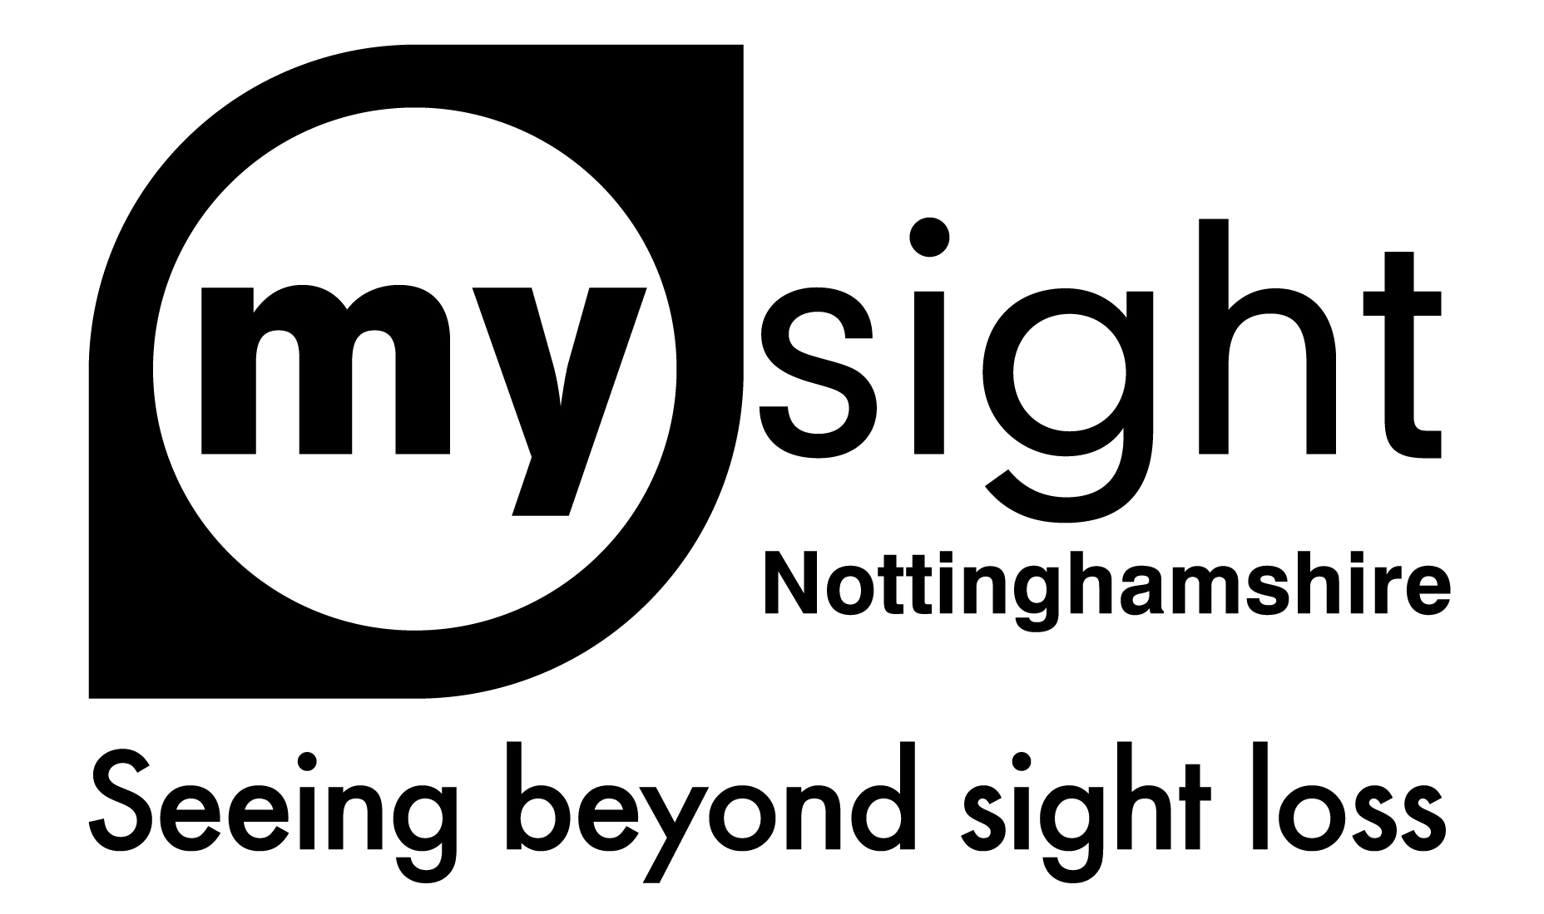

Customer Services Policy

Policy Statement
My Sight Nottinghamshire is committed to delivering outstanding customer care and customer service.

As an organisation, the interests of the Visually Impaired people we support are at the heart of everything we do and of those who work and volunteer with us and this ethos is something that is reflected in our attitude to customer service

For us excellent customer care is about treating others as you wish to be treated yourself and we aim to ensure that the quality of the customer experience is consistent and high regardless of how the Charity is contacted and who the customer / client deals with.

We are continually striving to improve services by encouraging open communication and feedback from all who come into contact with us.

Customer Service Guidelines
Service users, customers and members of the public can contact My Sight Nottinghamshire by telephone, letter, email, website, via social media or in person; our customer service policy is applicable to all forms of contact.

‘In person’ or Face to face contact includes the attendance of projects and services run by the charity, external events attended by the charity and fundraising activities, such as street collections and our charity shops.

Dealing with Correspondence and written enquiries
Employees will endeavour to respond to all correspondence / enquiries from the public, including letters, emails, social media and website enquiries, promptly (within 2 working days), clearly and politely.
The correct email signatures are to be used at all times, and E-mail auto response is to be used when out of the office. This message should state an alternative colleague’s contact details for urgent enquiries and the employees expected return to work date.

For accessibility reasons, please use either Ariel font in at least 14point or an accessible format for all written correspondence. You should avoid italics where possible and limit the use of underlined text. All text should be left justified, not centred or right justified.

The correct charity logo’s to be used wherever appropriate, and this relates also to the use of templates for letters, reports, etc.

The logo can be used with or without its strapline, in full colour or mono and with either the charity name as My Sight Nottinghamshire or My Sight Notts.

For clarification on the above, refer to the Brand Guidelines Handbook or speak to Marketing for advice.

Guidelines on appointments
All employees should wear their ID badges at all times.

Members of staff will see visitors punctually when an appointment has been made at the office or at an external venue. Visitors are to be seen within 5 minutes of any appointment that has been made. At external meetings members of staff should arrive 10 minutes early, dressed appropriately and wearing their ID badge.

If no appointment has been made, members of staff will see visitors as promptly as is reasonably possible and, where possible, given an idea of possible waiting times in order to help manage expectations.

Guidelines on answering telephone calls
Telephone calls should be answered in a timely and professional manner, ideally within 4 rings.

The phone should be answered with a greeting giving both the name of the charity and the person taking the call, for example ‘Good afternoon, My Sight Nottinghamshire, Joe Bloggs speaking, how can I help’?

If staff have answerphone facilities set up (either on their desk phone or work mobile) a suitable greeting should be recorded.

When transferring calls, ensure that the member of staff is available to accept the call. If this is not the case, the staff member who takes the call should do everything possible to help the caller. Staff should not provide a timescale for when the caller will receive a return call from the unavailable employee but should ensure that the employee is provided with all details necessary to return the call as promptly as possible when they are available (i.e. name, contact number, time and date or call)

Orders and sales
My Sight Nottinghamshire primarily deals with two types of sales and orders:
- Equipment sales via our support centre
- Fundraising Activities (including charity shops and event tickets)

The Services Manager is responsible for overseeing Equipment orders and sales and the Fundraising Manager is responsible for Fundraising Activities.

Equipment orders, sales and refunds
Orders
Most items in the support centre will need to be ordered in. Please ensure that the customer is given a rough idea of how long an item should take to arrive. If you are informed of any delay to an order by a supplier, this should be relayed to the customer.

Returns and Refunds
As items are generally ordered specifically for a customer, different rules apply depending on the item, issue and timescales involved.

If the item has developed a fault and is within the guarantee period - we will return it to the supplier for them to look at it. We cannot give a time frame for this but will keep the customer up to date.

If the item has developed a fault and is out of guarantee we can return the item to the supplier for them to look at (but generally they will make a charge for any repair)

If an item is not suitable but could not be tried in the shop, we are able to offer a refund.

When an item of ‘high value’ (anything over £50.00 including mobile phones, magnifiers and lighting) is being purchased, it is recommended that customers book an appointment to trial it in the support centre before purchase as once ordered they cannot be returned simply because it is not suitable. We have a duty of care to ensure that customers are aware of this.

Further details regarding to Equipment orders and sales procedures can be found in the EAC information pack

Fundraising
Orders
Orders for tickets for fundraising events should be dispatched within 2 working days.

In the event of an event being cancelled, customers will be contacted immediately to inform them and full refunds for tickets should be offered.
Online sales from the charity shops should be posted within 48hrs. A tracked service should be used.
Charity Shops Returns / Refunds Policy
My Sight Nottinghamshire endeavours to ensure that all items we sell in our charity shop are checked and tested before sale. In the unlikely event that the item you purchase is faulty, My Sight Nottinghamshire will happily issue a refund / credit note provided the item is returned within 28 days.

Credit notes/ exchanges / refunds for unwanted goods are issued at the manager’s discretion and on production of a sale receipt.
Online, mail and telephone order customers have the right to cancel their order for a limited time even if the goods are not faulty. We will offer a refund to customers if they’ve contacted us within 14 days of receiving their goods that they want to cancel. They have another 14 days to return the goods once they’ve contacted us. Once we have received the returned item a refund must be issued.

Implementation, Monitoring and Review of this Policy
The Chief Executive Officer has overall responsibility for implementing and monitoring this policy, which will be reviewed on a regular basis following its implementation and additionally whenever there are relevant changes in legislation or to our working practices.

Policy created on 02.03.22
Policy reviewed on
Julie Scarle, Marketing Manager

