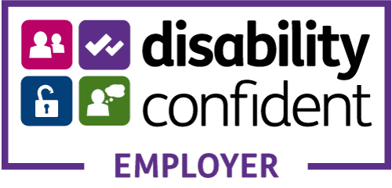


Job Title: Employment Adviser
Reporting to: Services Manager
Salary: £17,061 for 25 hours
Hours & Contract: 25 hours Permanent
Location: Based at My Sight Notts, 26-28 Heathcoat Street, Nottingham, NG1 3AA with travel across Nottinghamshire required.

Job Purpose
Provide information, advice, guidance and assistive technology support to people with sight loss to help them gain, retain or progress into employment. Support individuals to build their access technology skills, confidence and independence, as well as working with employers and key partner organisations.

Key Responsibilities
- Provide support with assistive technology for people seeking work which will enable job searches, applications and other tasks
- Provide access technology support and advice to people with sight loss who are currently in employment
- Provide advice and training in appropriate accessibility technology programmes and apps
- Liaise with employers and advocate for reasonable adjustments and Access to Work support
- Deliver one-to-one employment support, including assessments and action planning
- Support job applications, CV writing, interview preparation and transition into work
- Signpost and refer to in house services and external training, volunteering and other relevant support services where appropriate
- Work collaboratively with internal teams and external partners
- Undertake general administration and safeguarding responsibilities
- Ensure monitoring systems are in place to track activities, numbers and outcomes
- Ensure appropriate administration systems are in place to support the role
- Support the organisation to establish and maintain relationships with statutory and voluntary sector organisations
General
- Attend and participate in staff meetings and attend all training where required
- Attend supervision and appraisals
- Be familiar with all current and new policies and procedures and understand your duty to comply and implement them when necessary
- Any other duties deemed appropriate by managers

Person Specification

Essential
GCSE-level education (or equivalent)
Knowledge of assistive technology and workplace adjustments
Experience providing advice and guidance to vulnerable or marginalised groups
Strong communication, organisation and customer service skills
Ability to motivate and support individuals with low confidence
Ability to work independently and collaboratively
Willingness to travel and work flexibly

Desirable
Knowledge of employment practices and recruitment
Experience supporting people into employment
Awareness of services for people with sight loss and barriers to employment
Experience delivering training or working in partnerships to deliver training
Knowledge of the welfare benefits system
Experience working with people with disabilities

Enhanced DBS check required

